Advance Excel Assignment – 9

1. Margins are the empty space between the worksheet data and the left, right, top, and bottom edges of the printed page. You can manually adjust them to add more or less space around your worksheet data. There are three types of margins **Normal,** **Wide** and **Narrow.**

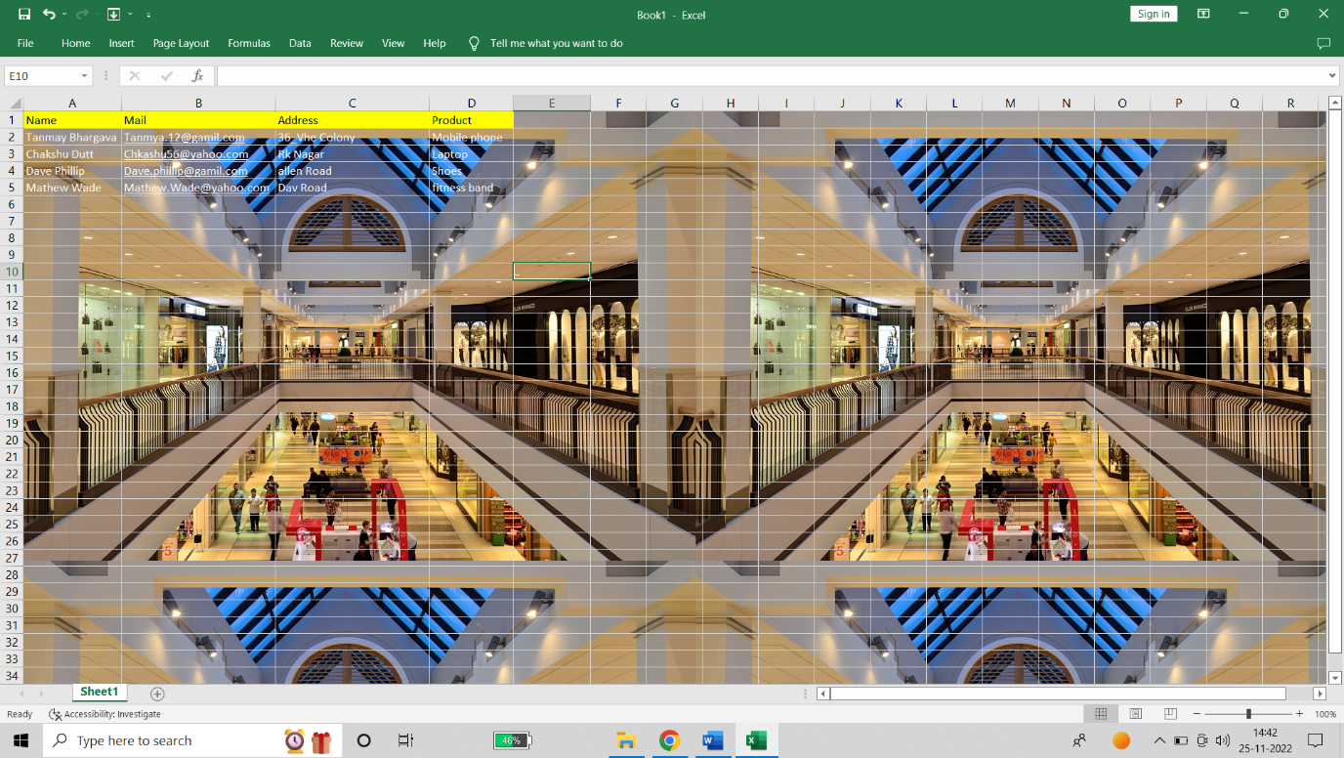

1. The Excel Freeze Panes option allows you to lock your columns and/or rows so that when you scroll down or over to view the rest of your sheet, the column and/or row will remain on the screen. We can freeze only the first column for your worksheet by following these steps:

* Go to View tab > Windows group > Freeze First Column.
* Select Freeze First Column.

1. **Unfreeze panes:** Unlock all rows and column to scroll through out entire worksheet.

**Freeze top row:** Keep top row visible while scrolling through entire worksheet.

**Freeze first column:** Keep the first column visible while scrolling through entire worksheet.

**Freeze panes**: Keep rows and columns visible while scrolling through entire worksheet (based on selection).

1. Since an Excel sheet is one of the core elements of the workbook, there are multiple core options to perform from the Sheet Options. We can access various sheet options by using the following ways:

* Ribbon Sheet Options
* Right-click Sheet Options

Let us discuss each in detail:

**Ribbon Sheet Options**

Excel has all the basic and advanced options present on its ribbon. Likewise, some quick sheet options are also present on the Excel ribbon and can be accessed by going to **Page Layout > Sheet Options.** It mainly has four toggle options: two for **Gridlines** and two for **Headings,** and they can be turned on and off by selecting and deselecting the checkboxes.

* **Gridlines:**
  + **View:** This option allows users to show/ hide gridlines within the active worksheet. Turning off this option removes the gridlines from the sheet and displays a blank Excel sheet.
  + **Print:** This option allows users to show/ hide gridlines on an Excel document that will be printed on paper.
* **Headings:**
  + **View:** This option allows users to show/ hide headings within the active worksheet. Turning off this option removes the headings from the current sheet's headers and footers.
  + **Print:** This option allows users to show/ hide headings on an Excel document, which is to be printed on paper.

**Sheet Options in Dialogue Box under Page Setup**

After clicking on the 'More' option (the arrow icon on the corner of the Sheet Options group on the ribbon), we get various sheet options. These sheet options are mainly used to adjust preferences for printing purposes. For instance, when we print Excel documents, gridlines are not usually printed. We can adjust preferences from sheet options to include the gridlines to print and manage other sheet options.

* **Print Area:** We can select the print area using this option. We can drag and select the area or range of cells by using the mouse.
* **Print Titles:**
  + **Rows to repeat at top:** This option helps us select the title to display at the top for corresponding rows.
  + **Columns to repeat at left:** This option helps us select the title to display on the left side for columns.
* **Print:**
  + **Gridlines:** This option can be enabled or disabled by selecting/ deselecting the checkbox. It helps us decide whether to show gridlines or not on printed Excel documents.
  + **Black & White:** Like the gridlines, we can select this checkbox to print the current Excel document in black and white color, even if we have the color printer attached.
  + **Draft Quality:** Selecting the checkbox associated with the draft quality allows us to print the Excel document using the printer's draft-quality settings.
  + **Rows & Column Heading:** We can select this option to display rows and columns headings to the printed Excel documents.
* **Page Order:**
  + **Down, then Over:** This option allows users to print the down page first and then the right pages.
  + **Over, then Down:** This option allows users to print the right pages first and then the down pages.
* **Print:** Clicking on this option gives a command to the device to print the current Excel document using the default printer.
* **Print Preview:** This option displays the preview of the Excel document that will be printed on paper.
* **Options:** This option allows users to choose layout type (portrait or landscape) and paper mode (A4, A5, etc.) for the Excel document to be printed.

**Right-click Sheet Options**

In Excel, the right-click with mouse button usually displays the context menu for the selected element. When we press the right-click on any Sheet tabs, Excel displays a list of options relevant to Excel sheets. The list includes various sheet options. However, this list is usually called the 'worksheet menu'.

**Insert**

As soon as we click the Insert, the new blank worksheet will appear in the current workbook.

We can also use the **New Sheet button** (Plus button next to sheet tabs) to add a new worksheet instantly.

We can also change the default number of worksheets to be added to each new workbook. For this, we need to go to **File > Excel options > General > Include this many sheets.**

**Delete**

To delete any desired sheet from the workbook, we must first press the right-click on a specific sheet on the sheet tabs and then select the **Delete** option from the list of sheet options.

**Rename**

To rename the worksheet, we can use the **Rename** from the sheet options after right-clicking on the desired sheet name on the sheet tab. After that, we need to enter the desired name for the specific worksheet and click the **Enter** key. The worksheet will be renamed instantly.

**Move or Copy**

When we need to duplicate the data from one sheet to another in Excel, we can use the Move and Copy option from the right-click sheet options list. We must first right-click on the sheet that we wish to copy and then select the **'Move and Copy'** option.

**View Code**

We can launch VB (Visual Basic) Editor by going to any sheet tab, right-clicking ad choosing the option 'View Code'. However, this option is rarely used to launch VB Editor.

**Protect Sheet**

If we protect any desired sheet within the workbook, Excel restricts users from editing or deleting the specific sheet. To protect any particular sheet in an Excel workbook, we need to right-click on the desired sheet and select the 'Protect Sheet' option.

**Tab Color**

The sheet tabs can be colored with the desired color. We can change the default sheet tab's color by using this option.

**Hide**

To hide a sheet, we need to click on the **Hide** option from the list of right-click sheet options. As soon as we click the Hide option, the corresponding sheet will no longer be visible on the sheet tabs.

**Unhide**

Like we hide the sheet in an Excel workbook, we can unhide the sheet in the same way. We need to select the **Unhide** option from the list of right-click sheet options, and the corresponding sheet will again be visible.

**Select All Sheets**

If we want to select all the workbook sheets at once, we can click on the 'Select All Sheets' option from the list.

**Additional Sheet Options**

Although Excel sheets have many tasks, the grouping, ungrouping of sheets, and switching between sheets are some essential ones that are not present as direct sheet options.

**Grouping worksheets**

Excel allows us to group multiple sheets simultaneously. It is helpful when we need to work with multiple sheets at once with some common data

**Ungrouping Worksheets**

When we have multiple sheets grouped in the workbook and wish to ungroup them, we need to right-click on any of the sheets in the group. This will open sheet options, as shown below:

**Switching between Worksheets**

When we need to view different sheets from the sheet tab, we usually click on the desired sheet name using the mouse. However, when the workbook has so many sheets, it becomes difficult to scroll through sheet tabs to find and click on them to switch to the desired sheet. In such a case, we need to press the right-click button on the scroll arrows in the lower-left corner of the Excel window, as displayed in the image below: